Election ‘24.

By: Adam J. Brewster and Coby J. Yang

**Submission for:** 2.1; 2.2; 4.1

**Presidency**

Our models for the key battleground states rely on two fundamental questions (our changing variables):

1. Are voters financially better off than they were four years ago?
2. Have Republicans or Democrats gained in their relative voter registration numbers along county lines?

Prediction:

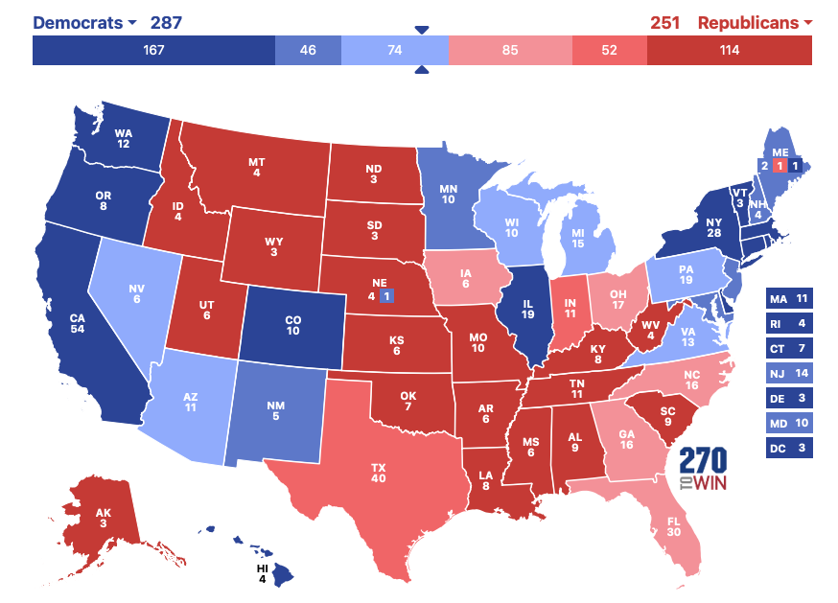

Overview of Results:

*National*

| Candidate | Total Votes | %Votes |
| --- | --- | --- |
| Kamala D. Harris | 79,391,675 | 51.20% |
| Donald J. Trump | 72,459,175 | 46.73% |

**Methodology (Swing States)**:

Presidential Vote Share 2.1, 2.2:

States with Voter Registration Data by Party:

The specification we used for Arizona, Nevada, Michigan, Pennsylvania, Georgia, Wisconsin, and North Carolina:

*Republican Vote Share*

predict_r24_amt = round(test1_coeff["(Intercept)"] +test1_coeff["rreg20_pct"] * rreg24_pct +test1_coeff["r12_r16_amt"] * r12_r16_amt +test1_coeff["CAINC416_420"] * CAINC422,

*Democratic Vote Share*

predict_d24_amt = round(test2_coeff["(Intercept)"] +test2_coeff["CAINC420"] * CAINC422 +test2_coeff["dreg20_pct"] * dreg24_pct +test2_coeff["d12_d16_amt"] * d12_d16_amt, 0)

*Third Party Vote Share*

predict_o24_amt = round(test3_coeff["(Intercept)"] +

test3_coeff["r12_r16_amt"] * r12_r16_amt +

test3_coeff["o16_o20_pct"] * o16_o20_pct +

test3_coeff["d12_d16_amt"] * d12_d16_amt

*Presidential Swing States[1]*

To measure whether or not voters were better off than they were four years ago we calculated the average effect of change in personal income along the 2020 and 2016 election results. We then used the resulting coefficient with the most recent personal income data from 2022 to determine the effect that county level economic changes would have on both candidates' vote totals. Additionally, we found the coefficient for registration along party lines in each swing state county to determine if either party’s strength in any of the swing states had changed between ‘20 and ‘24. After controlling for these factors we found that Kamala Harris wins the electoral college by 287-251.

For states without registration data by party (Michigan, Wisconsin, and Georgia) we omitted the registration by party coefficient and based the model on past election results (ideological swing) to predict which way the state would go this year.

[COMBINE SWING FINAL.Rmd]

*Presidential Safe States*

For the “safe states” we took a weighted computation of the popular votes for the Democrats and Republicans in each state. The 2020 results were weighed by 10% while the 2016 results were downweight by 15%. Our justification for this is that we expect for the margins in the safe states to remain around the same for each candidate due to each candidate not investing campaign resources into these states.

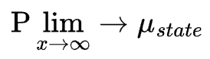 hence why our weighing structure is valid.

[National Presidential.Rmd]

**House of Representatives:**

**Methodology:**

For the House we focused on whether or not Trump would boost or hurt candidates running for congress in the 2024 elections. While we found Trump running behind incumbent Republicans in 287 house races our final results showed the republicans gaining in the house (winning around 230 seats). We determined this by first calculating the average number of votes that Trump earned in each congressional district in the ‘16 and ‘20 elections. Then, we found the average amount of votes that a generic Republican candidate earned in each district in ‘16 and ‘20. Finally, took the average of the democrats in each district and determined the winner based on who had the highest average percentage in a district during a Trump election year.

[House.Rmd]

**Data Sources:**

* Wikipedia
* Respective State Websites
* Bea.org
* PLSC 204 Provided House DataSet
* www.presidency.ucsb.edu

1. We used linear regression (backward stepwise) to find the relevant variables for coefficients to predict the vote share amount for swing states. The models from state to state follow mostly the same models, with some flexibility if a variable was statistically insignificant by a large amount.